Assignment - 1

**Q1.** Discuss the difference between:

1. Primitive and Non-primitive data types.

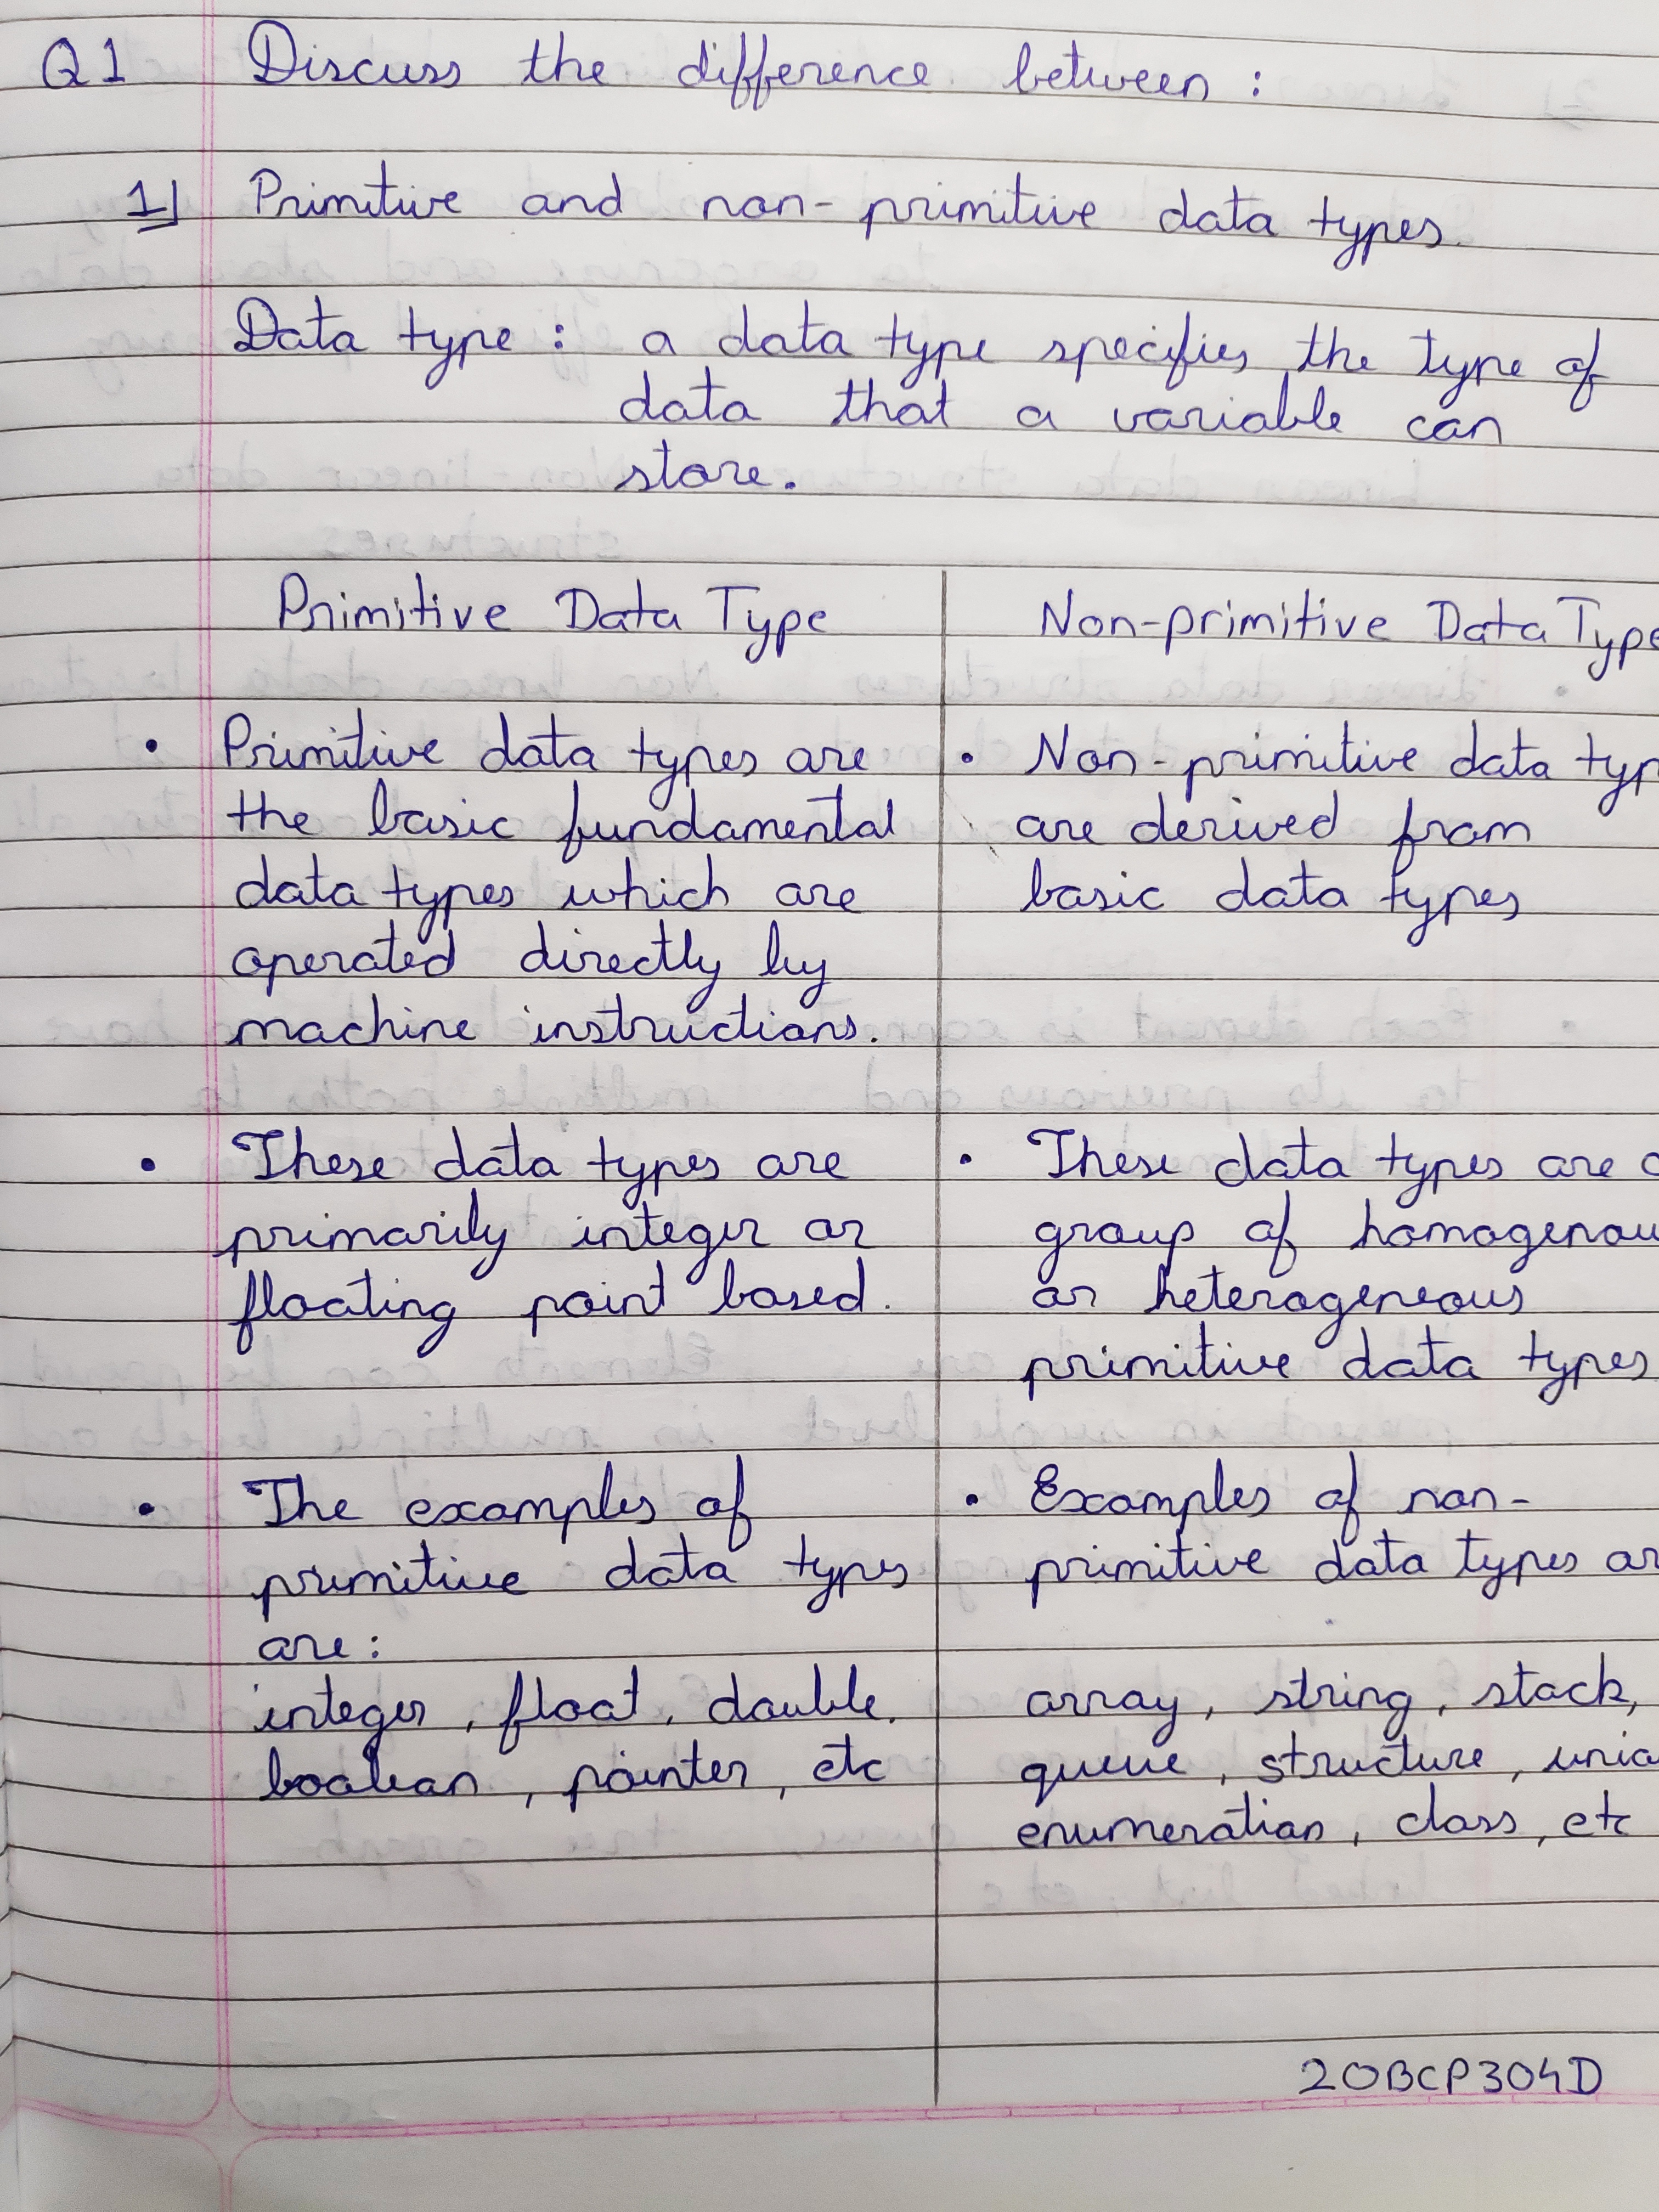

1. Linear and Non-linear data structures.

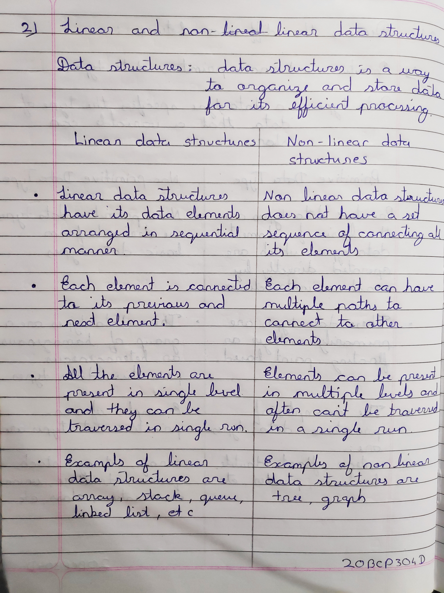

1. Space complexity and Time complexity.

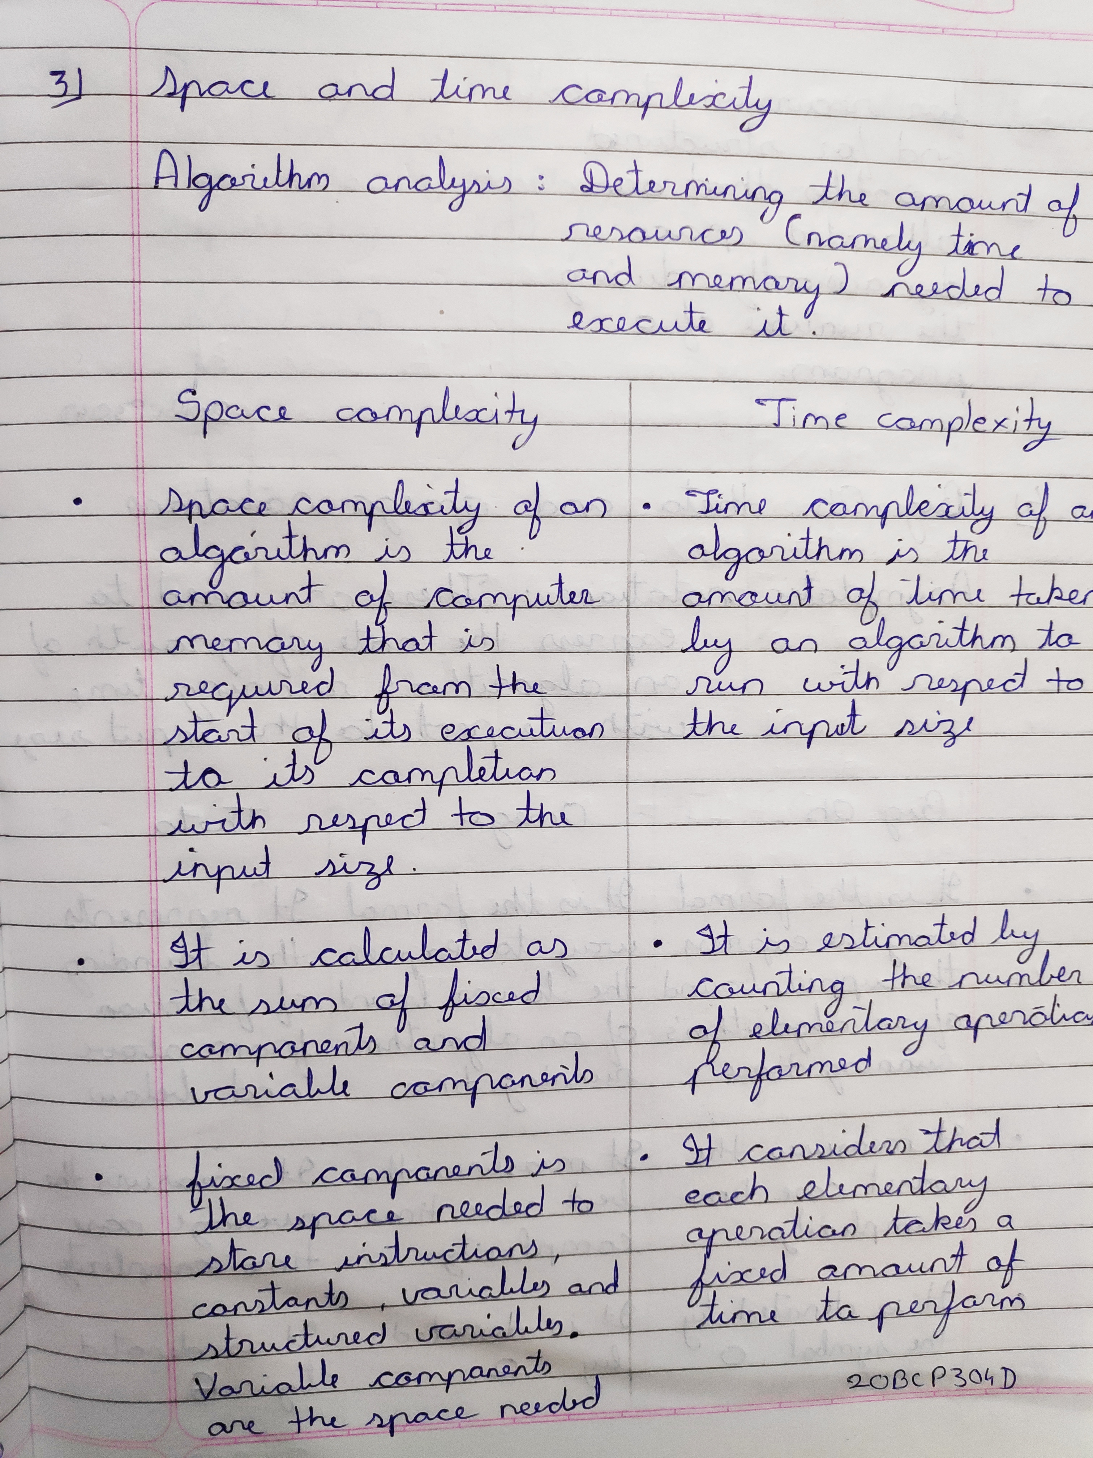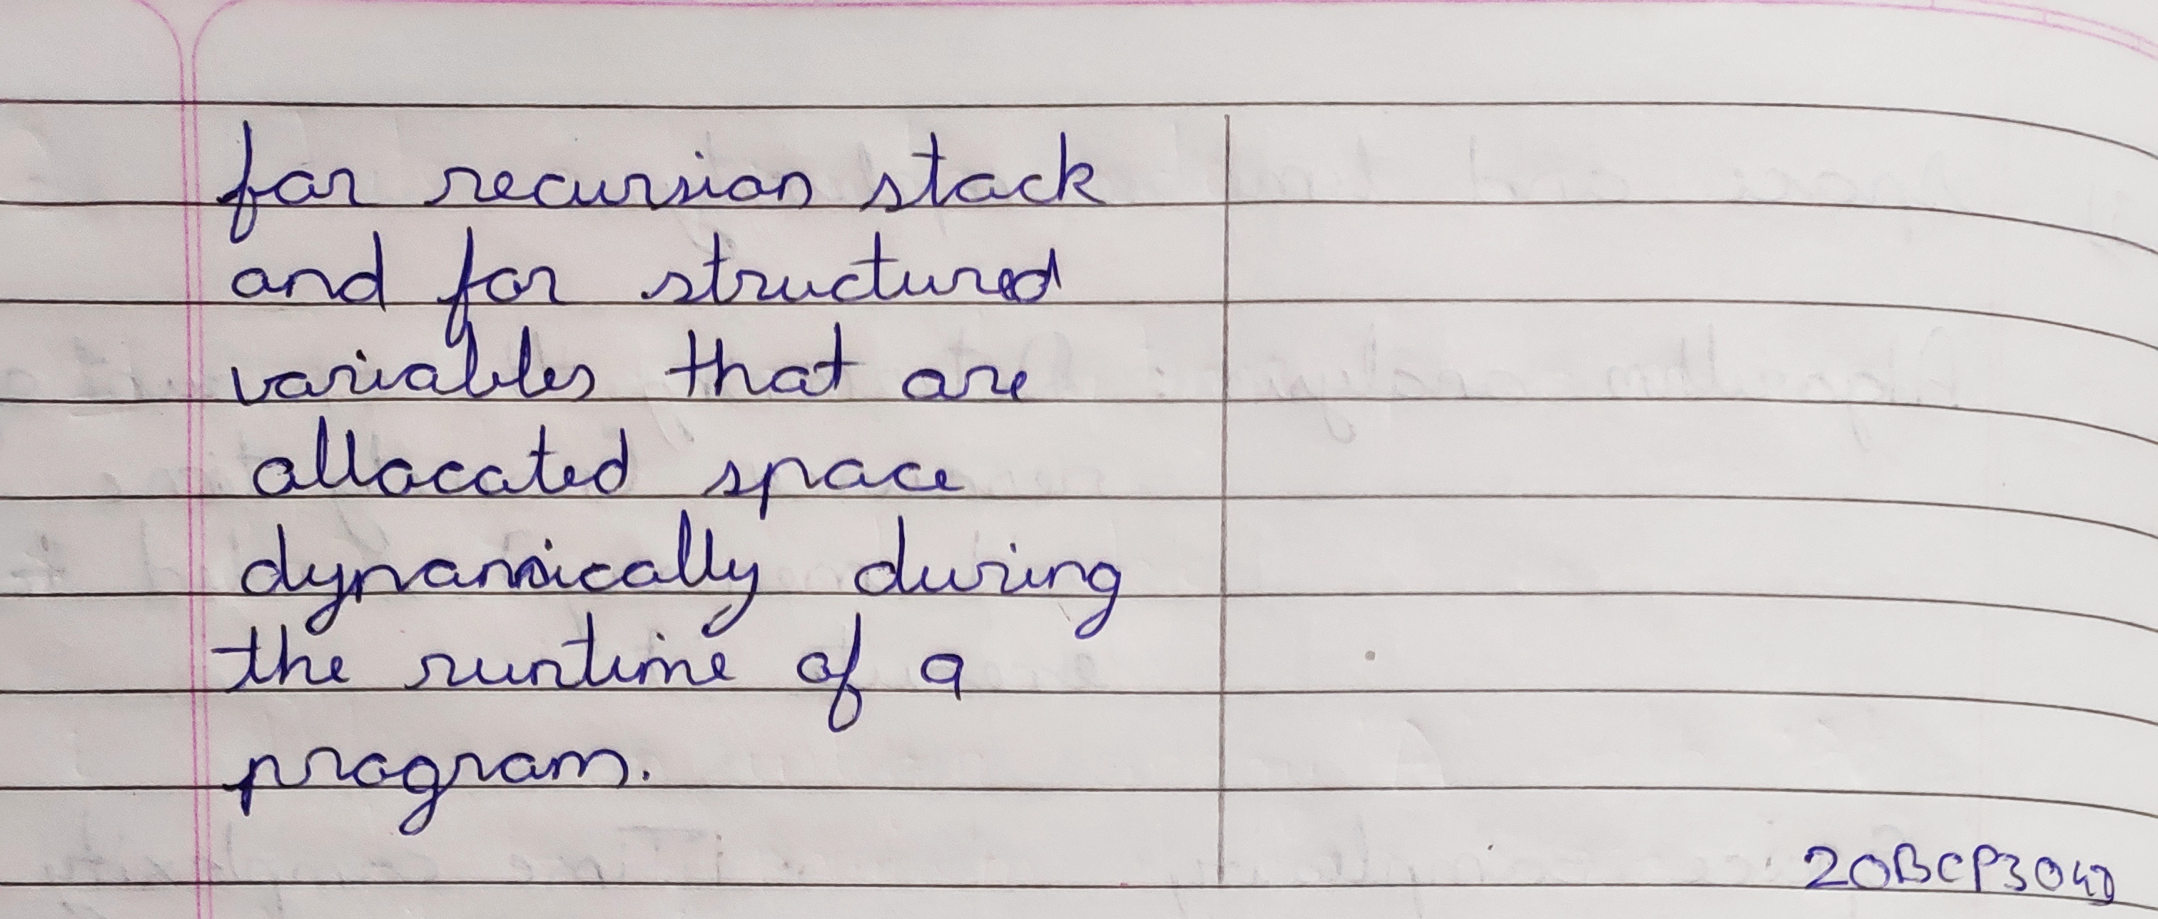

1. Big Oh, Theta and Omega notations.

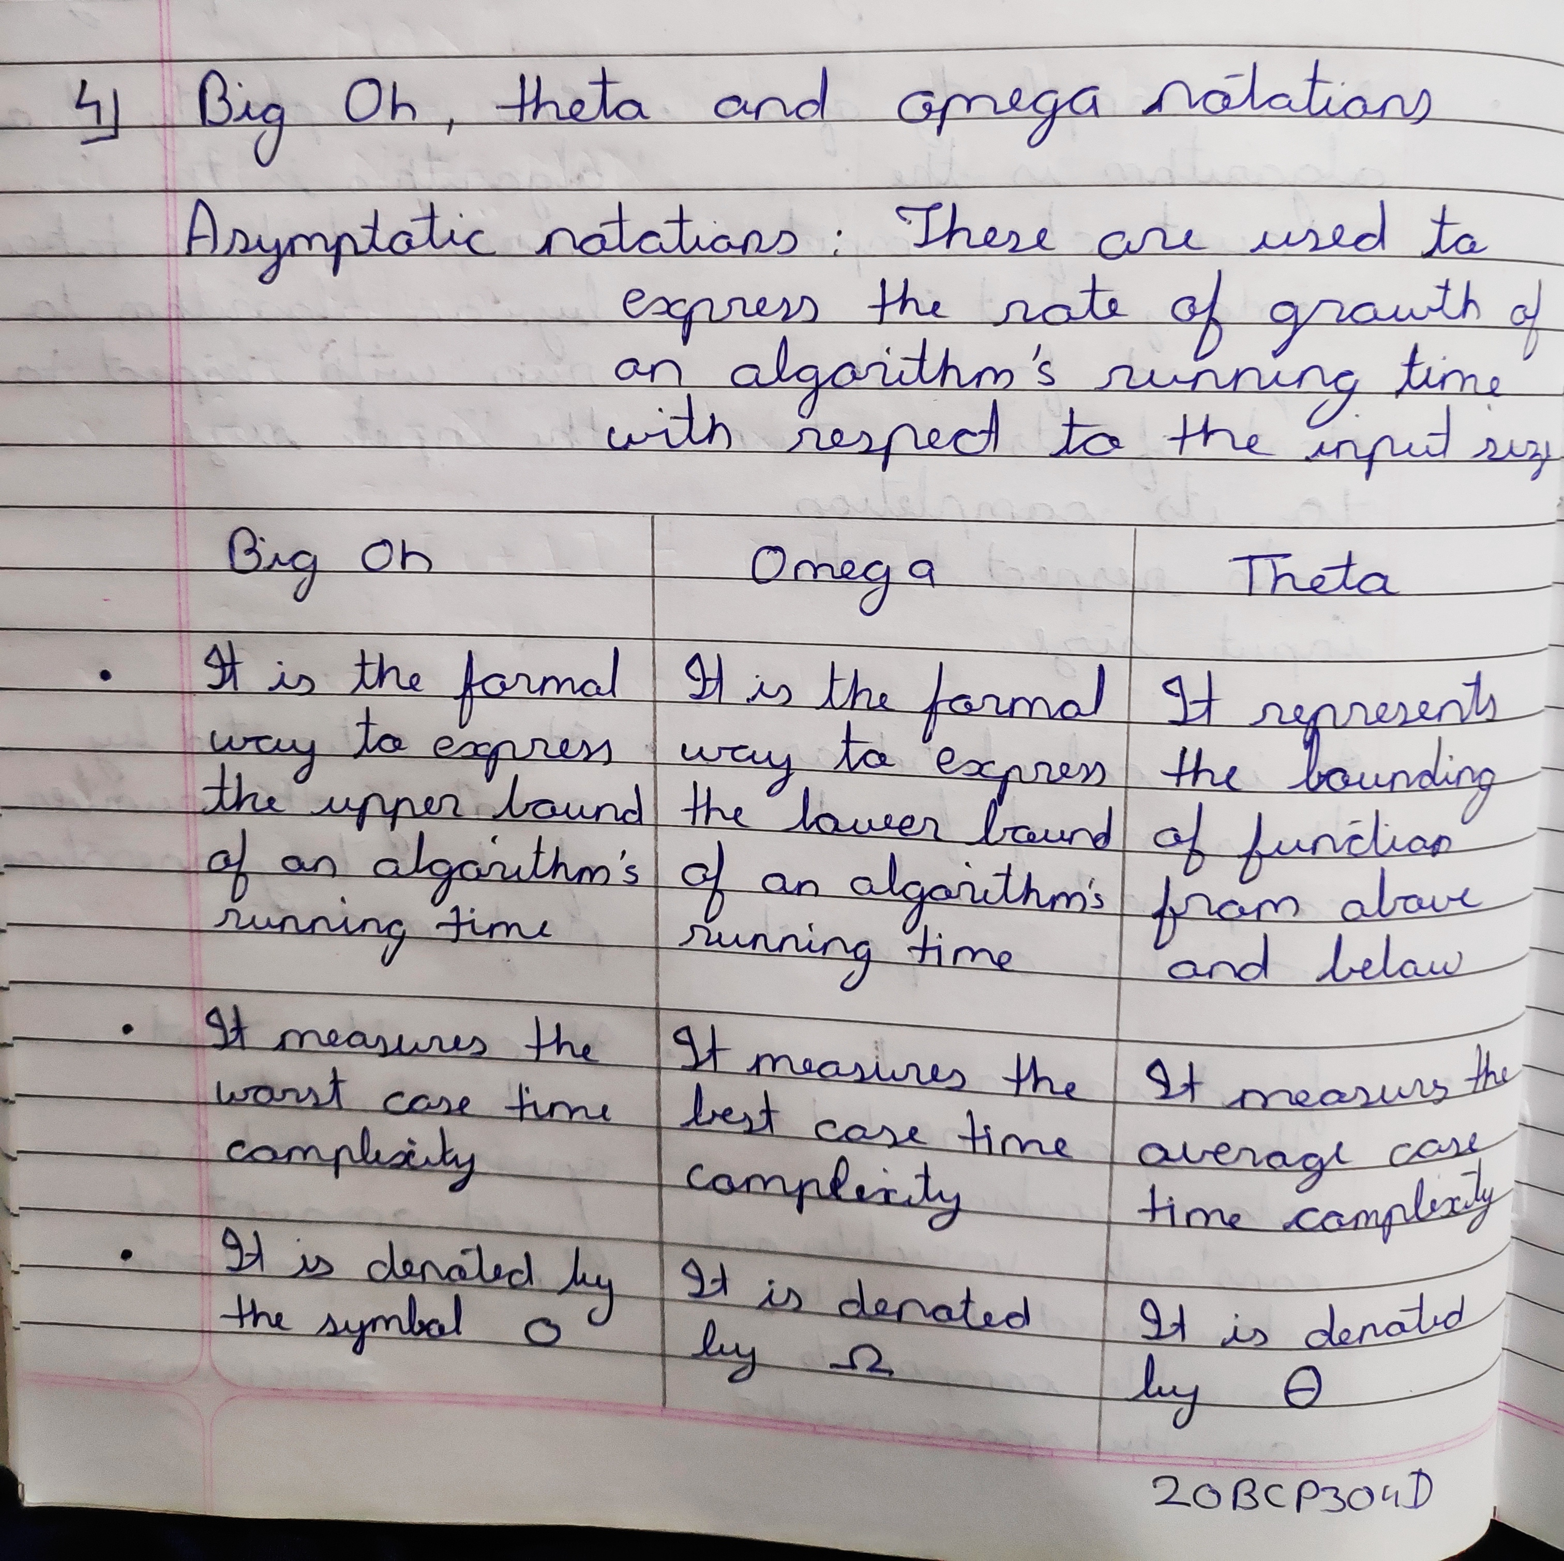

**Q2.** Draw graph for comparing the following function, where *n* varies from 0 to 5 (*x-axis* representing the *n* and *y-axis* representing *f(n)* function).

|  |  |
| --- | --- |
| *f(n) = n* |  |
| *f(n) = n2* |  |
| *f(n) = 2n* |  |
| *f(n) = n!* |  |

